INSURANCE APPLICATION PORTAL
@CREATIVITY THINK (9483175986/7019689991)

ABSTRACT:
Insurance Application Portal is a web application designed to streamline insurance policy management and claim tracking for agencies, offices, and customers. Users can browse policies, calculate premiums, submit applications, make payments, track claims, and access dashboards. Administrators manage policies, review claims, oversee analytics, and send promotional updates. Built using Django and Django Rest Framework for backend services and React with Recharts and Axios for frontend visualization, the platform ensures efficient policy lifecycle management, real-time tracking, and data-driven decision-making for both users and administrators..

INTRODUCTION OF THE PROJECT:
Managing insurance applications manually is complex, involving policy listings, premium calculations, claim tracking, and customer management. Insurance Application Portal provides a centralized web-based platform for both users and administrators. Users can browse and apply for policies, calculate premiums, make payments, and track claims. Administrators can add or edit policies, review claims, analyze data through dashboards, and send updates or promotional information. With Django handling backend operations and React providing interactive dashboards, the portal improves operational efficiency, transparency, and customer engagement in insurance services..

PROJECT OBJECTIVES:

• Provide a platform to browse and apply for insurance policies
• Enable premium calculation for different policies
• Facilitate online payments for policy applications
• Track insurance claims in real time
• Allow administrators to manage policies and claims data
• Generate analytics dashboards for informed decisions
• Improve communication and promotional outreach

PROBLEM OF THE STATEMENT:
Insurance agencies and offices face challenges in managing policy applications, premium calculations, payments, and claims manually, often leading to delays and errors. Customers also struggle with tracking claim status and understanding premium details. Insurance Application Portal addresses these challenges by providing a web platform where users can browse policies, calculate premiums, make payments, track claims, and access dashboards. Administrators can manage policies, claims, and analytics efficiently, ensuring transparency, speed, and accuracy in insurance operations..

MOTIVATION OF THE PROJECT:
• Streamline insurance policy application and claim processing
• Simplify premium calculation for users
• Enable online payment and tracking for policies
• Provide administrators with centralized data analytics
• Enhance transparency and operational efficiency for agencies

BLOCK DAIGRAM OF PROJECT:

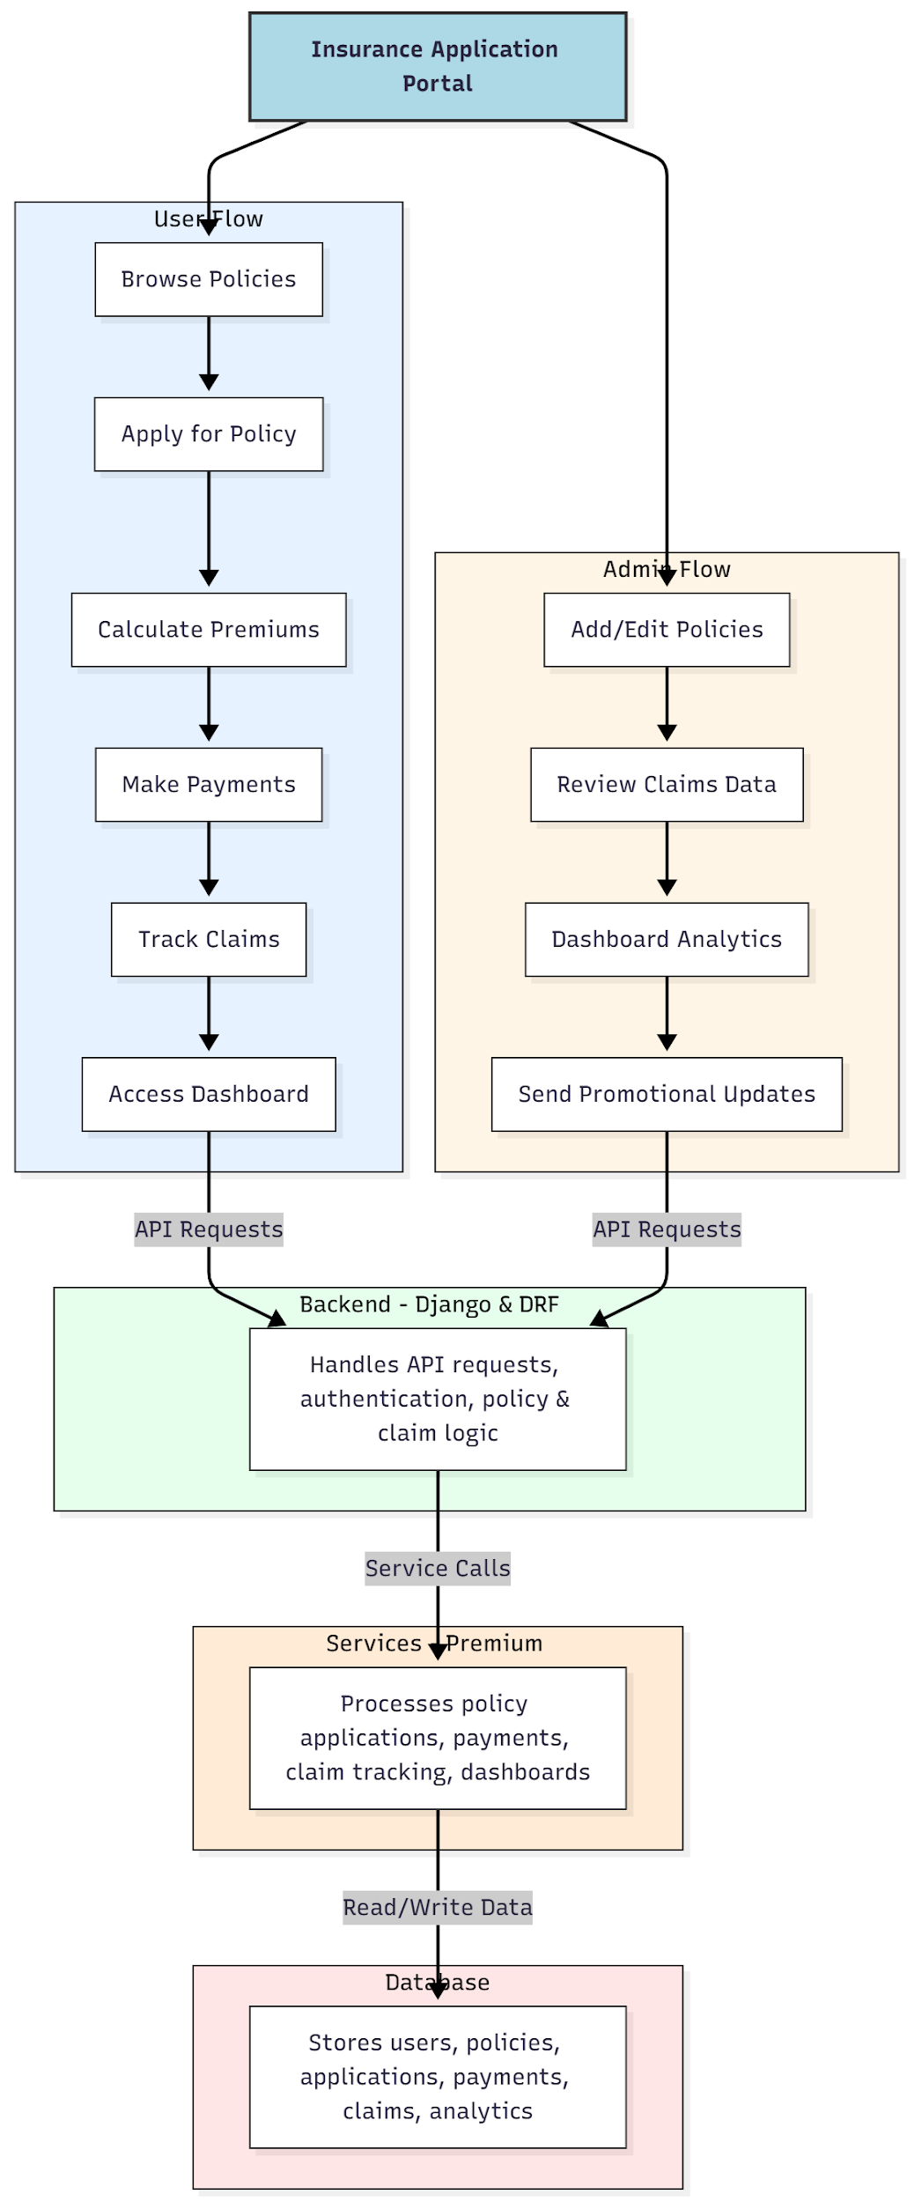

WORKING OF THE PROJECT:
Users browse available insurance policies, apply for selected policies, calculate premiums, make payments, track the status of claims, and view dashboards for monitoring. The backend handles API requests, authentication, and business logic related to policies and claims. Services manage premium calculations, payment processing, claim tracking, and dashboard updates. Administrators add or edit policies, review claims, send promotional updates, and analyze performance using analytics dashboards. This system ensures a seamless experience for both customers and insurance providers, improving efficiency, transparency, and data-driven decision-making..

SOFTWARE REQUIREMENT:
- Backend:
  - Python 3.x
  - Django
  - Django REST Framework
  - SQLite/PostgreSQL
- Frontend:
  - Node.js and npm
  - React.js
  - Axios
- Development Tools:
  - Visual Studio Code
  - Postman (for testing APIs)
  - Git/GitHub (for version control)
- Server/Deployment (Optional):
  - Gunicorn, Nginx, or Heroku/AWS for hosting

ADVANTAGES OF THE PROJECT:

• Streamlines policy application and claim tracking
• Simplifies premium calculation for users
• Provides online payment and dashboard access
• Enables administrators to manage policies efficiently
• Offers analytics for better decision-making
• Improves customer transparency and satisfaction
• Centralizes insurance operations in one platform
• Enhances communication with promotional updates

APPLICATIONS OF THE PROJECT:
• Insurance agencies and offices
• Customer-facing insurance portals
• Policy application and claim tracking systems
• Premium calculation and online payment systems
• Dashboard analytics for policy and claim management
• Customer engagement and promotional platforms
• Compliance and reporting for insurance operations
• Centralized management of policy lifecycle

REFERENCES:

- Django REST Framework Documentation — Django Software Foundation. Django Documentation. Available: https://docs.djangoproject.com/
- Django REST Framework. DRF Documentation. Available: https://www.django-rest-framework.org/
- React. React Official Documentation. Available: https://reactjs.org/docs/getting-started.html
- Redux. Redux Documentation. Available: https://redux.js.org/introduction/getting-started
- PostgreSQL Global Development Group. PostgreSQL Documentation. Available: https://www.postgresql.org/docs/
- MySQL. MySQL Reference Manual. Available: https://dev.mysql.com/doc/
- Git. Git Documentation. Available: https://git-scm.com/doc
- Node.js. Node.js Documentation. Available: https://nodejs.org/en/docs/
- Axios. Axios Documentation. Available: https://axios-http.com/docs/intro
- Socket.io Documentation – https://socket.io/docs/

